Project Contract deploy data ( the owner who’s deploy the contract ):

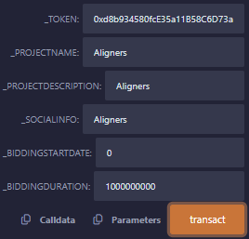

The owner can end the bidding at any time:



The owner can add vesting round by this function (passing round amount and IWO price)

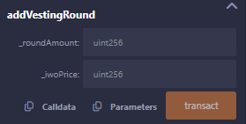

The customer can place a bid by this function pass allocation size and vesting length:

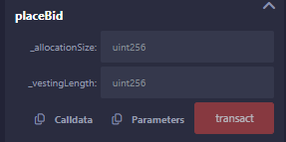

The customer can withdraw the tokens each month after finish the bidding, by this function

